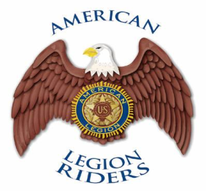
Year______
- New
- Renewal
Cash ____ Check _______
Copy to Finance _______
Copy to Adjutant _______
Mbrship Log Entry ______

CHAPTER _______
111 Your Street Address, Your Town, FL 111
Email: flalr???@gmail.com

FUTURE RIDER Application for Membership

About You: Complete this section in its entirety.

Name: Last ______________________ First __________________ Nickname__________________

Home Address: ____________________________________________________________________

City: ___________________________________________ State: __________ Zip: ______________

Home Phone: (____) _______- _________________ Cell Phone: (____) _______-________________

Parent/Legal Guardian: ______________________________________________________________

Birth Date: ____/____/________ email address: ___________________________________________

Check one
Member of: Jr. SAL Jr. Auxiliary Post #_________ Member #: ___________________

Emergency Contact Name: _______________________________ Phone: (____) _____-__________
This is who we can contact should something happen to you.

“I am joining as a Future Rider of the following Rider: __________________________________________________________
I will not be operating a motorcycle as an American Legion Rider but may be participating in American Legion Rider events as a passenger. If my status changes, I will request, complete, and submit a new Member Information Form.”

Signed: ___________________________________ Date: ____________________

Parent/Legal Guardian Signature: ________________________________________
Date: _____________________

“I, the undersigned, agree that the American Legion, and the American Legion Motorcycle Association (henceforth referred to as ‘The American Legion Riders’ or simply as ‘ALR’), shall not be liable or responsible for damage to property or injury to persons including myself during any ALR activities, even where the damage or injury is caused by negligence (except willful neglect). I understand and agree that all ALR members and their guests participate voluntarily, and at their own risk in all ALR activities. I release and hold the ALR Officers and the American Legion harmless for any injury loss to my person or property that may result through my participation in the ALR and/or their activities. I understand that this means that I agree not to sue the ALR officers, whether local, state, or national, nor the American Legion for any injury resulting to myself or my property in connection with ALR activities.”

All members must signify their understanding and certification of the relative section above by signing and dating here.

Approved By: ______________________________ Date: _____________________

