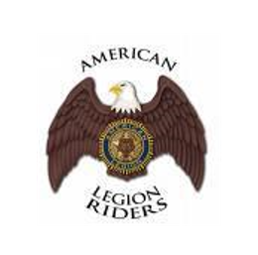
SAFETY PROCEDURES FOR AMERICAN LEGION RIDERS

- Food stops: When planning rides and working with the businesses to add them as a stop on your ride, request that some kind of food be served. It does not have to be a full meal as heavy appetizers work as well. They do not have to give away food but maybe ask for a few dollars or donations. Our riders would appreciate having meals along the way.
- Water: Request that all stops place coolers by the door with cold bottled water that would be accessible to riders coming in the establishment and leaving. Whether it is hot or cold weather, it encourages our riders to stay hydrated and have a water as a drinking alternative. If an establishment does not want to accommodate this request as bottled water is not costly – offer to provide cases of water to them or maybe rethink the stop altogether as this is important for the safety of our riders.
- Road Captain Training offered at the ALR Summit annually.
- Communication: Any group that is leading a ride should have uniform communication between the road captain and tailgunner/sweeper and any assistant road captains that may be in the middle on larger rides.
- Group size accommodation: Have enough road captains to spread the larger groups into safer, smaller groups.
- Behavior: Road Captains and Directors/Assistant Directors should always be vigilant in discouraging inappropriate behavior whether the riders are ALR or another group. We are not just representing the ALR but also the American Legion and should act accordingly. This should also be clearly stated in pre-ride safety briefings.
- Safety Cage: It might be good practice to have someone with a car go along on rides to be available to transport parts that might become disconnected or transport riders who for whatever reason cannot complete the ride and need a ride back. Most places that are stops on rides have no issues with storing a bike overnight if the rider cannot complete the ride.

Let’s all ride safely and responsibly and set an example for others!!!

