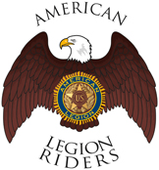

Department of Florida
The American Legion Riders

ACKNOWLEDGMENT OF THE ADOPTION OF THE STANDARD OPERATING PROCEDURES (SOP) DATED AND APPROVED ON 3/15/2020.

I, __________________________________, as the acting ________________________(title) of ALR Chapter #______ located in ______________________________________, FL
Acknowledges the Adoption of the American Legion Riders Standard Operation Procedures (SOP) this __________day of _____________ 20____.

“For the cause, NOT the applause”

