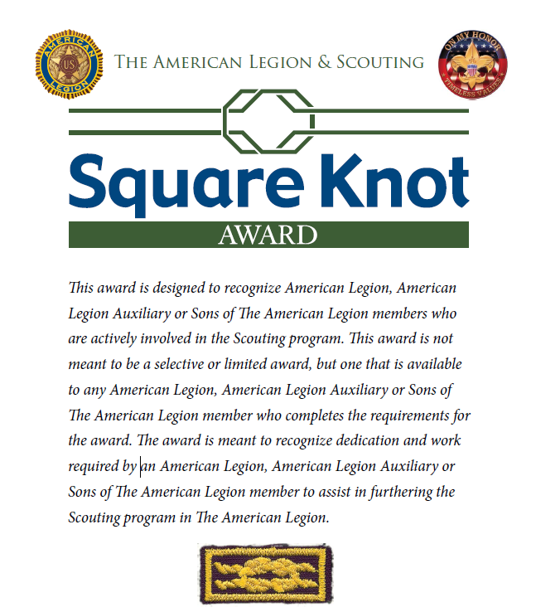

APPLICATION
NATIONAL AWARD APPROVAL

- Submit appropriate documentation (membership card, photocopies of course completion certificates, narrative of accomplishments, etc.) in order to fully document the attainment of the requirements as outlined in sections A, B, C, and D.

- Obtain the written endorsements of your American Legion post commander, American Legion Auxiliary unit president or Sons of The American Legion squadron commander and the department Scouting chairman, department adjutant and department commander that you have satisfactorily completed the requirements for this award. (A list of department headquarters addresses can be found on the back of the brochure to assist in obtaining the written endorsements of the department Scouting chairman, department adjutant and department commander.)

- Submit the appropriate documentation and written endorsements to the Americanism Commission, The American Legion, P.O. Box 1055, Indianapolis, IN 46206.

- Note: Application packets that lack the appropriate documentation or written endorsements will be returned.

AWARD REQUIREMENTS VALIDATION

SECTION A: SERVICE

REMARKS: Mr. Hewett met all criteria for this section. [Add remarks as required here. State up front if all criteria is met and/or if there is anything that requires amplification.]

CRITERIA: Member must fulfill items #1 and #2 below.

# | REQUIREMENT | DATE COMPLETED | REMARKS
1 | Be a current member of The American Legion, American Legion Auxiliary or Sons of The American Legion. | July 21, 2016; (PUFL) | Ruskin Post 389, Ruskin, FL; Member ID: 205098938. See Encl 1.
2 | Be registered in a Scouting leadership position at the Unit, District or Council level; or as a Chartered Organizational Representative (COR); or as a District/Council Member-at-Large; or as a Unit Commissioner. | November 20, 2017 | - 2012-2013: Pack 606 Tiger Den Leader  - 2013-2014: Pack 606 Committee Member/Treasurer, Wolf Den Leader  - 2014-2015: Pack 606 Committee Member; Unit Religious Emblem Coordinator; Unit Friends of Scouting Chair; BSA Timucua District Friends of Scouting Chair  - 2015-2016: Pack 606 Committee Member/Treasurer; Pack Trainer  - 2016-2017: Timucua District Committee Member at large  - 2016-2017: Pack 606 Committee Member/Treasurer; Pack Trainer; Arrow of Light Scout Den Leader; Friends of Scouting Chair  - 2017: Pack 1481 Cubmaster  - 2017: Troop 1482 Scoutmaster  - 2017-2018: Charter Organization Executive  - See Encl 2.

SECTION B: TRAINING

REMARKS: Mr. Hewett met all criteria for this section. He previously served as a Unit Leader and currently serves as the BSA Charter Organization Executive. The below five requirements do not apply to him at this time. However, he has completed those as well (Items # 1, 2, 3, 5, and 8). [Add remarks as required here. State up front if all criteria is met and/or if there is anything that requires amplification.]

CRITERIA: If serving as a Unit Leader, complete five of the following:

# | REQUIREMENT | DATE COMPLETED | REMARKS
1 | Complete the Cub Scout Leader Basic Training course. | April 14, 2013 | See Tiger Cub Den Leader Position Specific Training Certificate. He is the current BSA GTBAC Trainer for the Cub Scout Leader course. See Encl 3.
2 | Complete the Boy Scout or Sea Scout Leader Basic Training course. | May 13, 2017 | See my.Scouting training completion report; See Encl 4.
3 | Complete the Venturing Crew Leader Basic Training course. | February 2, 2018 | See Venturing Crew Advisor Position Training certificate; See Encl 5.
4 | Complete the Commissioner Basic Training course. | N/A | N/A
5 | Be current in “Youth Protection” training. | February 20, 2017 | See my.Scouting training completion report; current until 2019; See Encl 4.
6 | Be current in American Red Cross “First Aid and CPR.” | N/A | N/A
7 | Earn the Scouter’s “Training Award.” | N/A | N/A
8 | Attend and complete a Wood Badge or Sea Badge training program. | May 21, 2015 | S4-86-14-1; Beaver Patrol. See Encl 6.
9 | Attend a Philmont training course. | N/A | N/A

REMARKS: Mr. Hewett met all criteria for this section. He currently serves as the BSA Charter Organization Executive. He fulfilled items # 1, 2, and 4. [Add remarks as required here. State up front if all criteria is met and/or if there is anything that requires amplification.]

CRITERIA: If serving as a Chartered Organizational Representative (COR), or as a District/Council Member-at-Large, or as a Unit Commissioner complete three of the following:

# | REQUIREMENT | DATE COMPLETED | REMARKS
1 | Attend a National Community Relationships Scouting training seminar. | October 28, 2017 | See the minutes from the 5th Annual American Legion Scouting Program Conference held at the BSA National HQ, Dallas, TX hosted by the BSA National Alliances Team and the community relations training that took place at the seminar; See Encl 7.
2 | Participate in a Chartered Organizational Representative (COR) training course | February 2, 2018 | See training certificate; See Encl 8.
3 | Complete a BSA District staff-training course. | N/A | N/A
4 | Attend a Wood Badge or Sea Badge training program. | May 27, 2015 | See Wood Badge Course S4-86-14-1 training certificate; See Encl 6.
5 | Attend a Philmont training course. | N/A | N/A

SECTION C: TENURE

REMARKS: Mr. Hewett met all criteria for this section. [Add remarks as required here. State up front if all criteria is met and/or if there is anything that requires amplification.]

CRITERIA: Member must fulfil the item #1 below.

# | REQUIREMENT | DATE COMPLETED | REMARKS
1 | Serve a total of three consecutive years in a Scouting leadership position at the Unit, District or Council level; or as a Chartered Organizational Representative (COR); or as a District/Council Member-at-Large; or as a Unit Commissioner. | November 20, 2017 | - 2012-2013: Pack 606 Tiger Den Leader  - 2013-2014: Pack 606 Committee Member/Treasurer, Wolf Den Leader  - 2014-2015: Pack 606 Committee Member; Unit Religious Emblem Coordinator; Unit Friends of Scouting Chair; BSA Timucua District Friends of Scouting Chair  - 2015-2016: Pack 606 Committee Member/Treasurer; Pack Trainer  - 2016-2017: Timucua District Committee Member at large  - 2016-2017: Pack 606 Committee Member/Treasurer; Pack Trainer; Arrow of Light Scout Den Leader; Friends of Scouting Chair  - 2017: Pack 1481 Cubmaster  - 2017: Troop 1482 Scoutmaster  - 2017-2018: Charter Organization Executive  - See Encl 2.

SECTION D: PERFORMANCE

REMARKS: Mr. Hewett met all criteria for this section. He completed items # 2, 4, 6, 7, 8, and 9. [Add remarks as required here. State up front if all criteria is met and/or if there is anything that requires amplification.]

CRITERIA: While serving in a Scouting leadership position at the Unit, District or Council level; or as a Chartered Organizational Representative (COR); or as a District/ Council Member-at-Large; or a Unit Commissioner complete a minimum of five of the following:

# | REQUIREMENT | DATE COMPLETED | REMARKS
1 | Serve a minimum of two years as a Post Chartered Organizational Representative for Scouting and demonstrate success with your units in terms of growth in program. | N/A | N/A
2 | Assist your post, district or department to raise funds to support Scouting. Participate with a local BSA District or Council Friends of Scouting fundraising effort. | May 21, 2015 | - Awarded the James E. West Fellowship Award for raising over $1,000 for BSA; See Encl 9.  - Was the Pack 606 Friends of Scouting Chair. On behalf of the Council FOS Chair, went to multiple District units and gave FOS talks to raise funds for the Council. These tasks were specific Wood Badge tickets (S4-86-14-1; Beaver Patrol). See Encl 6.  - Motived SAL Squadron 148 to donate over $3,500 for the Boy Scout program in 2017 to purchase a new enclosed trailer. Support will be reported on the Post 148 2017-2018 CPR.
3 | Participate as member of a BSA District or Council  Membership/Relationships committee and represent  The American Legion. | N/A | N/A
4 | Assist in organizing or reorganizing a Cub Pack, Scout Troop, Sea Scout Ship, or Venturing Crew chartered by an American Legion post. | December 15, 2015 | - In December 2015, drafted a new unit set of BSA Unit bylaws, restructured leaders and committee members, and created new SOPs. Briefed the Post 148 Commander and obtained approval his approval of the new by-laws reorganizing the Post’s BSA Unit on 15 December. Implemented strategy immediately. SOPs are now hung on the Department of Florida website for all BSA Units to utilize. See Wood Badge tickets, Encl. 6 and website: https://www.floridalegion.org/wp-content/uploads/2017/10/Pack-1481-Bylaws-FINAL-2-AUG-2017.pdf  - Qualified and submitted for the BSA National William D. Boyce New-Unit Organizer Award. See Encl 10.
5 | Participate in the Eagle Scout of the Year program at the post, district or department level. | N/A | N/A
6 | Make contact with Scout troops and venturing crews in your area through visits, roundtables or other means and solicit their participation in the National High School Oratorical Contest, Junior Shooting Sports Program, Boys State, American Legion Baseball and other Americanism programs and document the results of your efforts. | November 2016 – January 7, 2017 | - Beginning in November 2016, as the 15th District Boy Scout Chairman, visited multiple BSA Troops within Timucua District and the Timucua District Roundtables. Encouraged all units, including siblings and friends, to spread the word about the Oratorical program. In January 2017, Post 148/Post 389 held its first Oratorical Contest in decades organized and led by Rick Hewett, who also served as the Post 148 Oratorical program chairman. 15th District recruited 19 total contestants for the 2017 year, of which 14 were a directly attributed to Rick Hewett’s recruiting efforts.  - See the Post 148 Commander’s remarks about Hewett’s efforts and the Oratorical Contest here at the Post 148 Newsletter:  http://www.americanlegionalafiapost148.org/FEBMAR2017NewsletterColor.pdf  - See photograph of the Post 148/Post 389 2017 Oratorical Contest incorporating Scouts from BSA Timucua District. Picture is on page 18 of the 2017-2018 Department of Florida Scouting Program Manual found here: https://www.floridalegion.org/wp-content/uploads/2018/01/scoutingmanual_012018.pdf
7 | Recruit manpower from your post or district to support a Scout activity such as a camporee, bicycle rodeo, merit badge day or other related event to help further American Legion recognition in support of the Scouting program. | December 9, 2017 | - Gave multiple BSA volunteer recruitment speeches at Post 148 and Post 389 general meetings.  - Incorporated a monthly Cub Scout Pack section into Post 148’s newsletter and requested volunteers. See one example here: http://www.americanlegionalafiapost148.org/OCT-NOV_2016_Newsletter_Color.pdf  - Gave a BSA volunteer recruitment speech at the September 2016 15th District meeting after then National Vice Commander Paul Martel.  - Organized and led an American Legion Scouting event in the Central Area on December 9, 2017. Recruited Scout Units from within the BSA Greater Tampa Bay Area Council and Central Area to participate in a traditional campfire program with songs and skits for the veteran residents of the James A. Haley VA Center. Four American Legion chartered BSA Units participated from three posts. The Department POW/MIA Chairwoman also participated. The event was widely advertised in Timucua District. The American Legion left a plaque at the VA Hospital to commemorate the inaugural event.  - See Department-wide “Legion Link” article written by Rick Hewett to recruit for a Department-wide centennial Scouting event: https://www.floridalegion.org/wp-content/uploads/2018/01/2018_Jan_Vol26_Issue6.pdf
8 | Develop and carry out or participate in an American Legion program to recognize the leaders of Scouting programs in your post, district or department. | December 15, 2015 | - Developed a first-ever set of BSA Unit bylaws which implemented a leader development and recognition program by the Post for Wood Badge tickets. These same example BSA Unit Bylaws are now available on the Department of Florida’s Scouting program page. See Wood Badge tickets, Encl. 6 and website: https://www.floridalegion.org/wp-content/uploads/2017/10/Pack-1481-Bylaws-FINAL-2-AUG-2017.pdf  - Recognized Post 148 adult Scouting Leaders at every subsequent pack Blue & Gold Banquet for past 2 years. The result has been motivation for other qualified adults to join both the BSA Unit and the Post.  - American Legion awards are purchased for Post 389’s 3 Scouting Units (Pack 3891, Pack 1481, and Troop 1482). See Encl 11.
9 | Promote and coordinate the development of a network of department American Legion Scouting Team members to assist in the development of Scouting within The American Legion. | 2017-2018 | - Drafted and published American Legion Department of Florida Legion Link article promoting Legionnaires to participate in centennial Scouting events. See Department-wide “Legion Link” article: https://www.floridalegion.org/wp-content/uploads/2018/01/2018_Jan_Vol26_Issue6.pdf  - Gave Department Scouting report speech at the 2017 Fall Convention.  - Taught classes on Scouting at the 2016 and 2017 Fall Conferences.  - See material created and presented by Hewett at www.floridalegion.org/scouting  - Recruited Legionnaires to be on the Eagle Scout of the Year Award selection committee and developed District and Area Scouting Program Chairmen.
10 | Earn the Cubmaster Award, Cub Scouter Award, Den Leader Award, Den Leader Coach Award or Tiger Cub Coach Award. | N/A | N/A
11 | Earn the Scoutmaster Award of Merit. | N/A | N/A
12 | Earn the Crew Advisor Award of Merit. | N/A | N/A
13 | Earn the Scouter’s Key, Scouter’s Training Award, or Distinguished Commissioner Service Award. | N/A | N/A

